Run times

|  |  |  |  |  |
| --- | --- | --- | --- | --- |
| maximumTilesX | tileHeight | Naïve Run Time | Lum Run Time | KD Run Time |
| 200 | 32 | 81.32 | 19.848 | 4.85 |
| 300 | 32 |  | 29.296 | 6.55 |
| 400 | 32 |  | 62.606 | 11.39 |
| 600 | 32 |  | 177.4 | 32.74 |
| 200 | 100 |  | 18.52 | 5.15 |

Notes:

I only ran Naïve for one of them because I quickly realized how long it takes to run. Below are the pictures based on maximumTilesX and tileHeight. An increase in maximumTilesX makes clearer photos.

Visualizations – Just the KD-web images

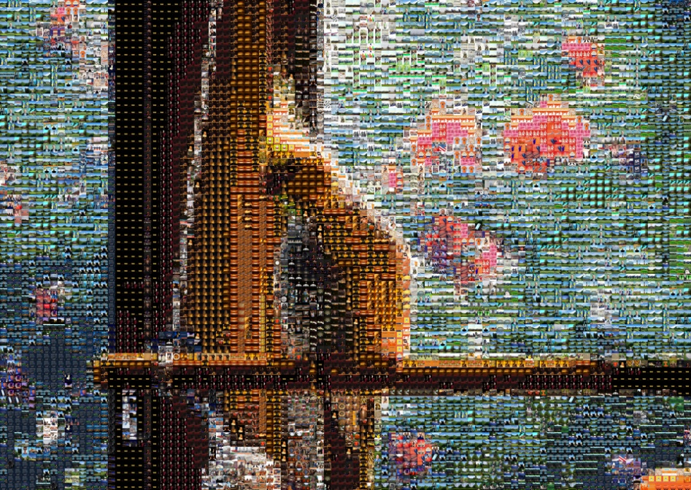

Figure : 100x32

Figure : 200x32

400x32

Figure 4: 600x32

Figure 5: 200x100

Figure 6: 300x32